**LIBRARY MANAGEMENT**

**SYSTEM**

**\*\*\*\*\*\***

**Installation Guide**

**1. Open SQL Server 2008, enter login name and password to login system of SQL Server 2008**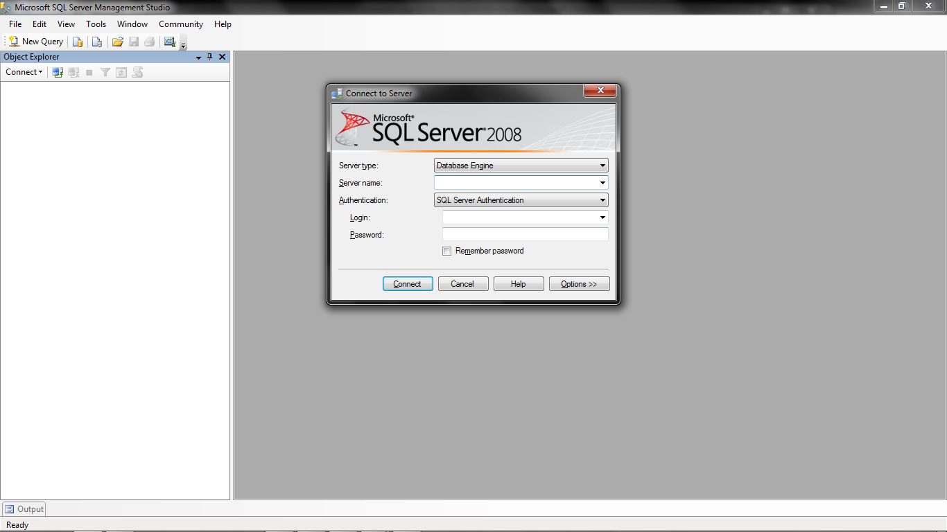

**2. Right click on “Database” and choose “New Database…”**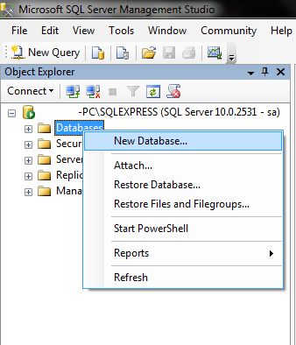

**3. Database name will be “ElevatorSystem” , then click OK**

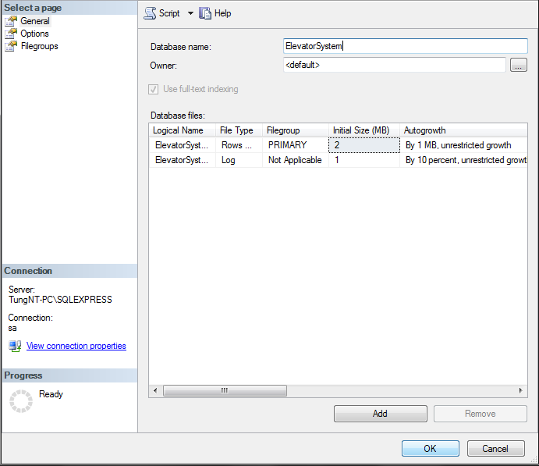

**4. Then open file “MyProject.sql”**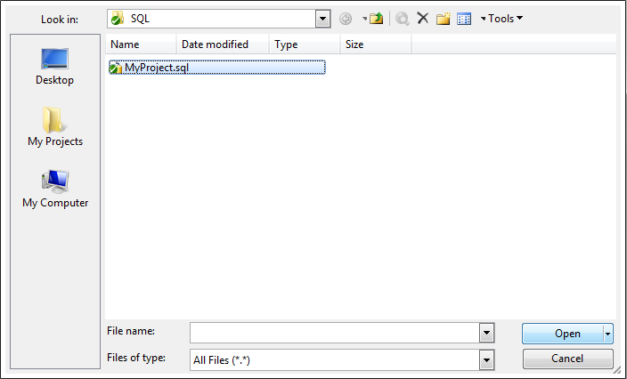

**5. Then Press F5 button**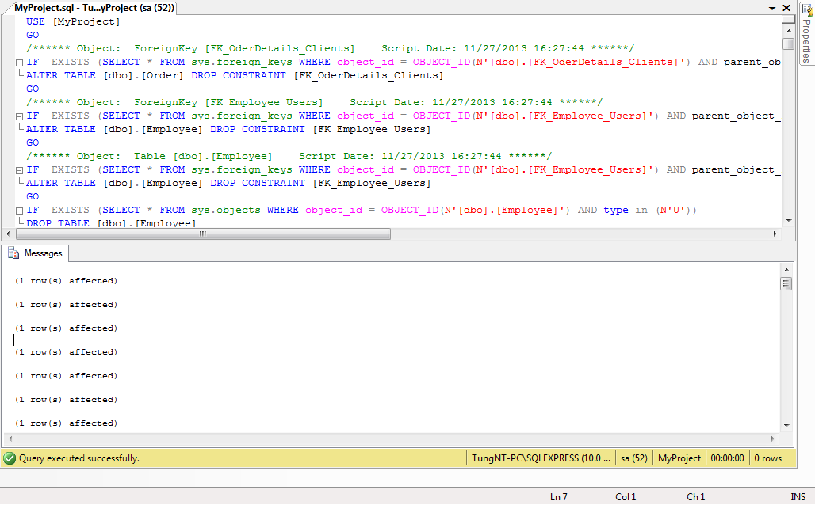

**6. After that open “Elevation System” then click on Option button to config database**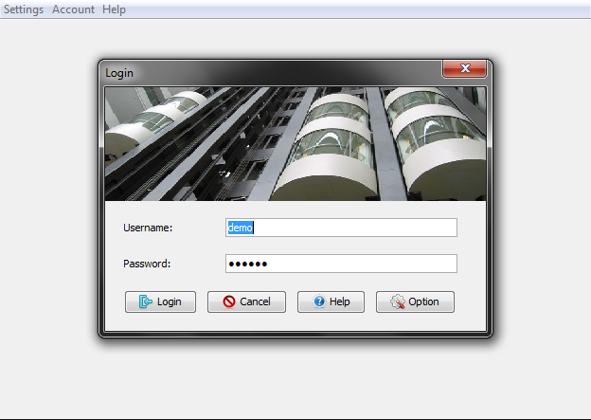

**7. The details will be (Server name: local host; Port: 1433; Database: ElevatorSystem; Username: sa; Password: 123456;). Then click “Test and connect”**

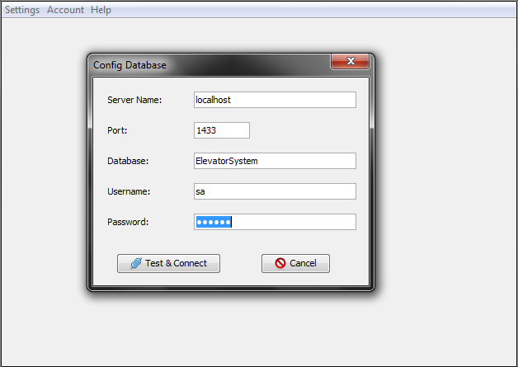

**8. After that, input your user name and password to login**

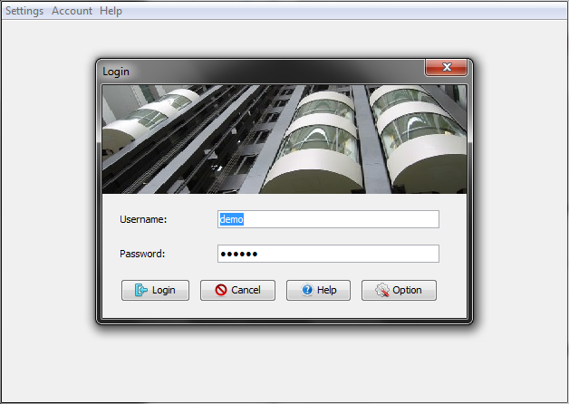

For more help and information about product please contact:

Group: 6

Email : - [toanlmgc00250@fpt.edu.vn](mailto:toanlmgc00250@fpt.edu.vn)

- [phuonglhgc00112@fpt.edu.vn](mailto:phuonglhgc00112@fpt.edu.vn)

- [tungntgc00186@fpt.edu.vn](mailto:tungntgc00186@fpt.edu.vn)

Thanks you!